Asi Se Dice 1 Cap. 1 MC900056793[1] MC900057893[1] MC900060319[1]

  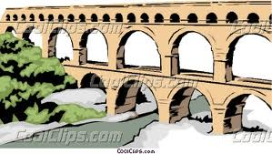

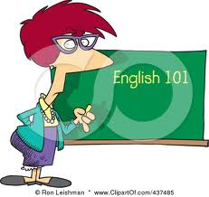 MC900436129[1]  C:\Users\Jenni\AppData\Local\Microsoft\Windows\Temporary Internet Files\Content.IE5\N6F6M1Z5\MC900370274[1].wmf

 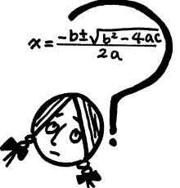 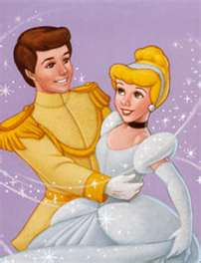 

|  |  |  |  |
| --- | --- | --- | --- |
| **argentino** | **chileno** | **colombiano** | **cubano** |
| **dominicano** | **ecuatoriano** | **guatemalteco** | **mexicano** |
| **norteamericano** | **peruano** | **puertorriqueño** | **venezolano** |

    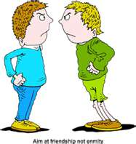 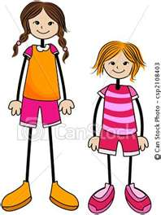 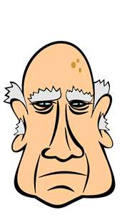

|  |  |  |  |
| --- | --- | --- | --- |
| **definite articles**  **the** | **indefinite articles** **a, an, some** | **agreement** | **Noun/adjective endings** |

  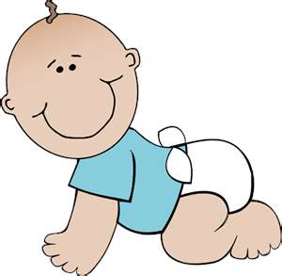

 C:\Users\Jenni\AppData\Local\Microsoft\Windows\Temporary Internet Files\Content.IE5\82TZ8BE9\MC900089056[1].wmf  MC900232606[1] MC900232605[1]  MC900437980[1] 

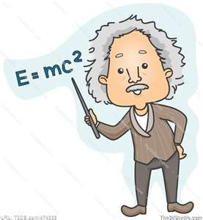 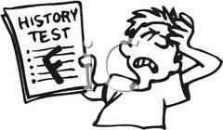 C:\Users\Jenni\AppData\Local\Microsoft\Windows\Temporary Internet Files\Content.IE5\82TZ8BE9\MC900251124[1].wmf 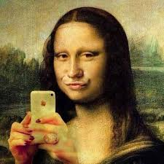

MC900235379[1] 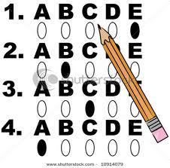 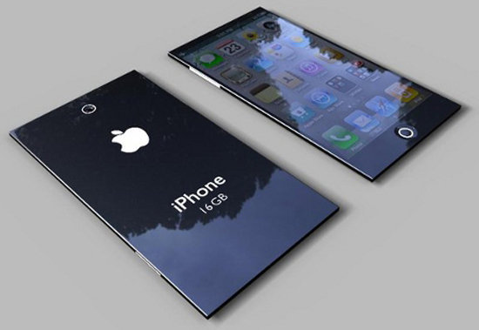 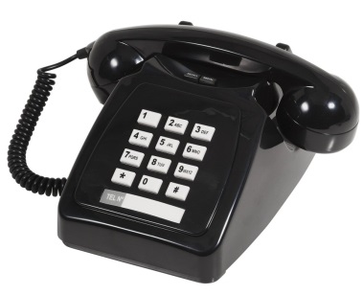

|  |  |  |
| --- | --- | --- |
| **también** | **bastante** | **muy** |
| **pero** | **¡Mucho gusto!** | **¡Oye!** |